

**AMERICAN INTERNATIONAL UNIVERSITY–BANGLADESH (AIUB)**

**FACULTY OF SCIENCE & TECHNOLOGY**

**OBJECT ORIENTED PROGRAMMING 2**

**Fall 2023-2024**

**Section: M, Group: 02**

**PROJECT ON**

***Event Management and Booking System***

**Supervised By**

**TASLIMUR RAHMAN**

**Submitted By**

|  |  |  |  |
| --- | --- | --- | --- |
| **Name** | **ID** | **Contribution** | **%** |
| 1. MARUF, MMUNTASIR | 22-46620-1 | Home Page, Browse Events, Event registration, Payment, Recharge, Admin Panel and Generation of Recharge cards. |  |
| 2. MD. NURUZZAMAN | 22-46042-1 | Settings Page Account Settings, Password change), Recharge Page (Front end) |  |
| 3. SADMAN SAMIR RAFITH | 22-46018-1 | Sign In Page and User Creation, Password recovery (Front end) |  |
| 4. SAMIAN BIN JOARDER | 22-47734-2 | History Page, Event History |  |

Date of Submission: **January 2, 2024**

Table of Contents

**ER Diagram** 3

**User Story** 4

**1. User Story of User:** 4

**a. Customer:** 4

**b. Organizer:** 4

**2. User Story of Admin:** 5

**Form Images** 5

**Schema Diagram** 18

# **ER Diagram**

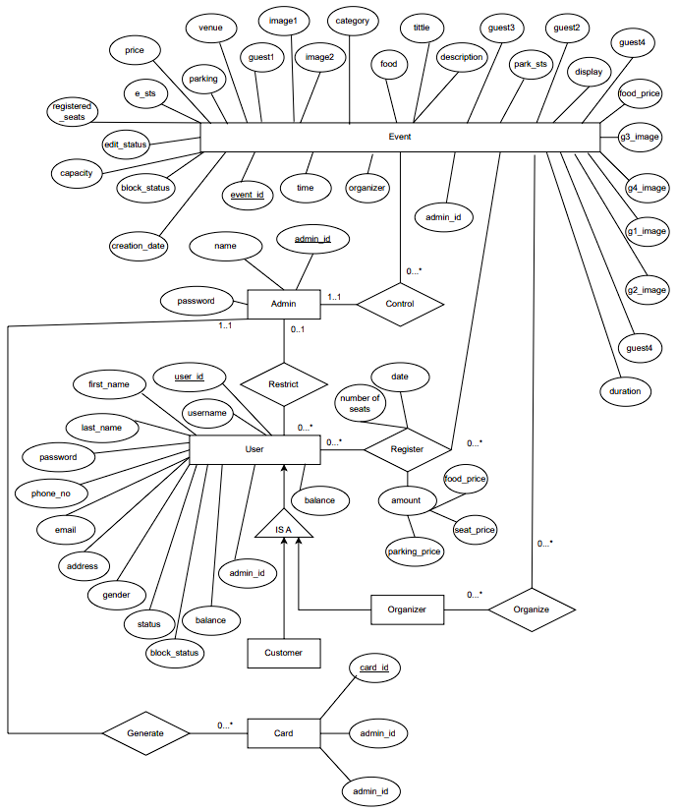

ER diagram of the Project Database

# **User Story**

The user types in this project are:

1. User
   1. Customer
   2. Organizer
2. Admin

## **1. User Story of User:**

### **a. Customer:**

After creating a new account (Sign Up) all Customer (Users and Organizers) are considered Regular users. With only the ability to register events.

A user can,

* Log in to their account.
* Update personal information and password after login.
* Reset password by email verification.
* Browse events that are created by organizers.
* Register multiple events.
* Choose the facilities offered by the organizers at their events.
* Edit registered events one day before the event date.
* Unregister events one day prior to the event.
* Recharge using purchased token provided by admins.
* View history of events registered.

### **b. Organizer:**

A user can send a request to admin to be an organizer. If admin accepts the request

then the user becomes an organizer.

An organizer can,

* Do all the tasks that a user can do.
* Organize events for other users to register.
* Set facilities to their events.
* Update the details of the events, one day before the event date.
* Delete any events.
* See the history of all events created by the organizer.
* Can see the users who have registered to their events.
* Can lock and unlock an event while creation or after creation of the event. Controlling the

editability of registered users to update their registration.

## **2. User Story of Admin:**

An admin is separate from the user. Admins can be added by only other admins. Admins have abilities that a normal User/ Customer does not have.

An admin can,

* Add another admin.
* Log in to their account by special username.
* See all the events ever created by the organizers.
* Monitor the details of all the users signed into the application.
* See the events registered by each user.
* See users who have registered to an event.
* Block users to prevent them from registering any event.
* Seize an event to prevent any further registration.
* Generate recharge cards for the users to add balance to their account.

# **Form Images**

Form 1: Account Creation

Form 2: User Login

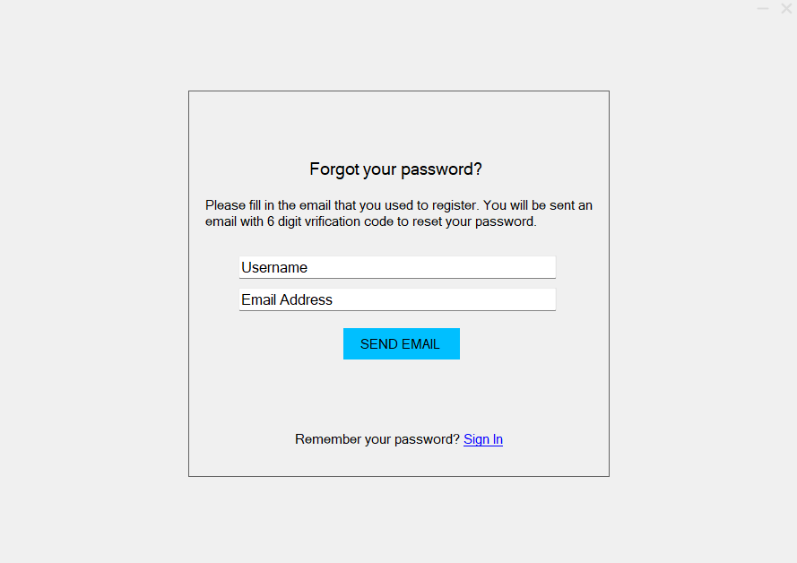

Form 3: Forgot Password

Form 4: Email Verification

Form 5: Home Page

Form 6: Browse Events

Form 7: Event Registration

Form 8: Payment

Form 9: Registered Events

Form 10: Update Registration details

Form 11: Event Creation

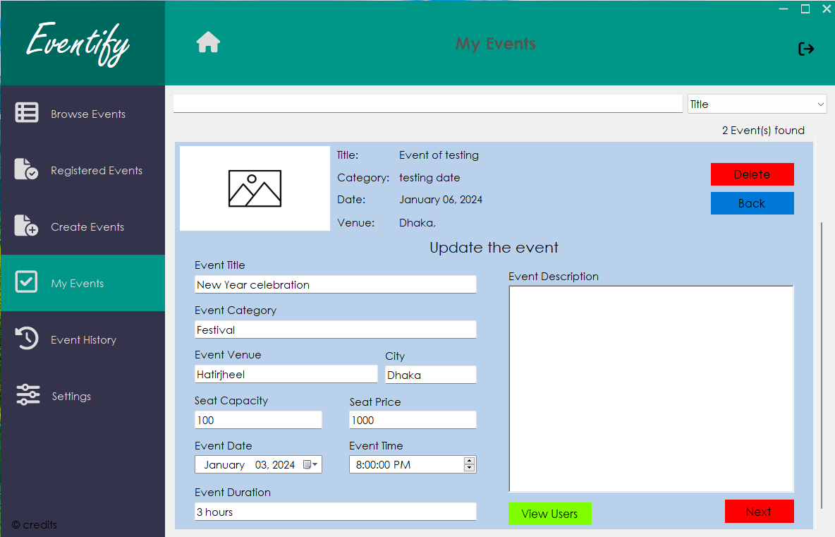

Form 12: Update Created Event

Form 13: Event History

Form 14: Settings Page

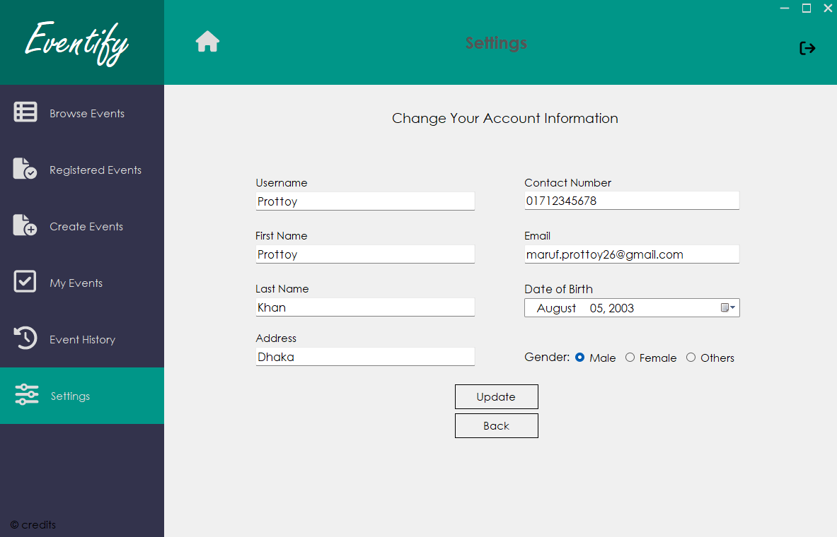

Form 15: Change Account Information

Form 16: Change Password

Form 17: Recharge

Form 18: Admin Panel (User Details)

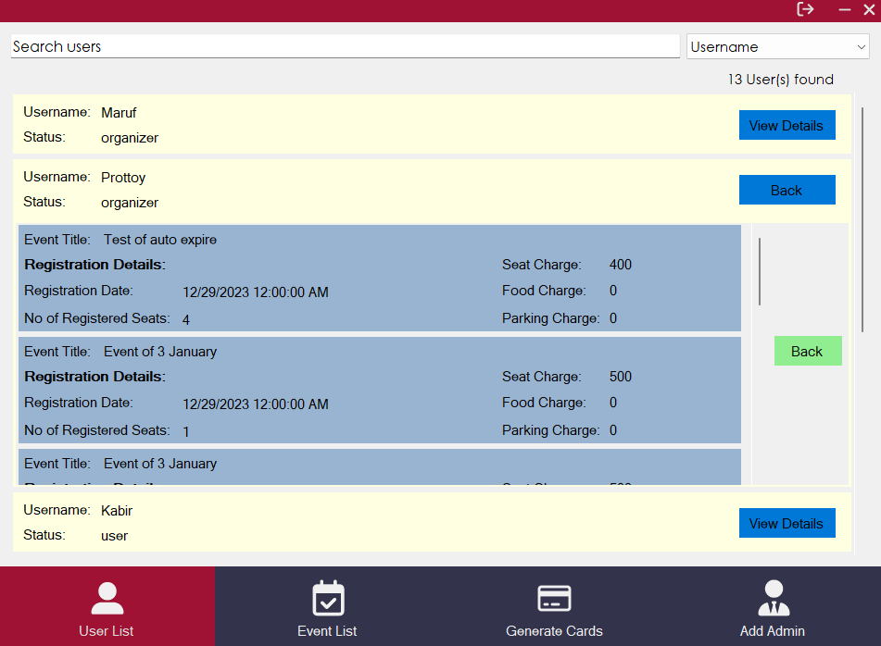

Form 19: Admin Panel (Registered event of user)

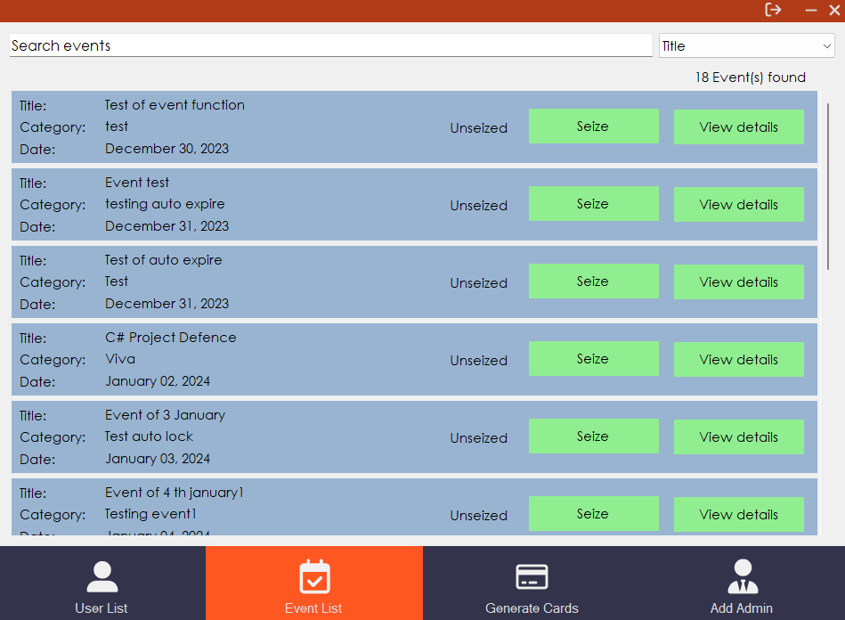

Form 20: Admin Panel (Event List)

Form 21: Admin Panel (Event Details)

Form 22: Admin Panel (Registered Users)

Form 23: Admin Panel (Generate cards)

Form 24: Admin Panel (Add Admins)

# **Schema Diagram**

Schema diagram of the Project Database